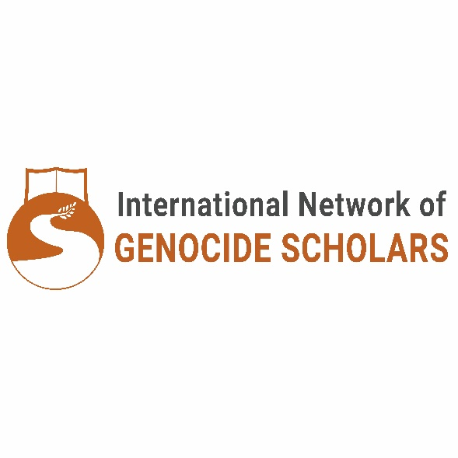

Call for Papers INoGS 10th International Conference

**Disguised Violence: Old and New Demonstrations of Genocides, Massacres, Disappearances, and Mass Atrocity**

6-9 July 2026

University of Brasília, Brazil

Organized by the International Network of Genocide Scholars (INoGS)

Co-organized and hosted by University of Brasília, Brazil.

**Conference Theme**:   
This conference invites scholars and practitioners and artists to critically explore the evolving and often disguised forms of genocides, massacres, enforced disappearances, and mass atrocities. While traditional conceptions of these phenomena usually emphasize overt acts of violence, this conference seeks to expand the discussion to include systemic, covert, and contemporary manifestations, opening up an interdisciplinary space to interrogate the limits and possibilities of these terms. We aim to foster dialogue on new forms of mass violence, including those related to ecological destruction, digital spaces, cultural erasure, and forced migrations, while reflecting on historical and ongoing colonial and structural oppressions. Furthermore, the conference underscores the importance of studying transitional justice, restorative justice, and alternative conflict resolution mechanisms, as these approaches provide critical frameworks for addressing past atrocities, promoting accountability, and paving the way for sustainable peace in divided societies.

Hosting a conference on genocide in Brazil holds profound significance, particularly given the historical and ongoing atrocities in Latin America, including those against Indigenous peoples and Afro-descendant populations. The region’s history is marked by colonial violence, systemic oppression, and cultural erasure, which continue to resonate in contemporary forms of exclusion and structural inequality. In Brazil, Indigenous communities face land dispossession, environmental destruction, and threats to their survival, while Afro-descendant populations endure the legacies of slavery through systemic racism, police violence, and socio-economic marginalization. By situating the conference in Brazil, this conference aims to recognize the complexities of disguised violence in situ, through a comparative lens, and in other regions across the globe, both historical and ongoing. We are committed to a dialogue which acknowledges these deeply rooted injustices, provides a platform to amplify marginalized voices, and fosters critical discussions about genocide and mass violence in a context that exemplifies their composite and multifaceted manifestations.

**Themes and Topics of Interest:**Submissions are welcome on (but not limited to) the following themes:

1. **Contemporary Genocides and Systemic Violence:** Analyses of modern genocidal practices and how they manifest through economic, cultural, political, or technological systems.
2. **Colonialism and Violence Against Indigenous Peoples:** Historical and ongoing patterns of violence, dispossession, and erasure faced by Indigenous communities globally.
3. **Racial Violence against Afro-Descendant Communities:** Examining systemic racism, police brutality, socio-economic exclusion, and other forms of violence disproportionately targeting Afro-descendant populations, as well as their resistance and resilience in the face of such oppression.
4. **Transitional Justice and Truth Commissions:** Exploring mechanisms of transitional justice, including truth commissions, reparations, and institutional reforms, as tools for addressing past atrocities and promoting accountability, reconciliation, and social healing.
5. **Missing Persons and Enforced Disappearances:** Investigating the patterns, motivations, and impacts of enforced disappearances in diverse geopolitical contexts, while highlighting the profound challenges faced by families and communities in dealing with fear, misinformation, and unresolved grief.
6. **Authoritarian Governments, Dictatorships, and Violence:** Analyzing the role of authoritarian regimes and dictatorships in perpetuating systematic violence, including state-sponsored repression, surveillance, and the suppression of dissent.
7. **Comparative Analyses of Genocide and Mass Violence:** Cross-cultural or historical studies that examine commonalities and divergences in the occurrence of mass atrocities.
8. **Climate Change and Ecocide:** Assessing the intersection of environmental destruction, climate-induced displacement, famine genocide and mass violence.
9. **Migration, Refugee Camps, and Statelessness:** Exploring the dynamics of forced migration, violence in refugee settings, and the systemic precariousness faced by displaced populations.
10. **Paramilitary Forces and Private Perpetrators:** Examining the role of non-state actors in perpetuating violence and the challenges of holding them accountable.
11. **Cultural Genocide and Bans on Cultural Expression:** Addressing the erasure of cultural identities and practices through systemic policies and societal pressures.
12. **Gendered Violence in Mass Atrocities:** Exploring how gender intersects with genocidal practices, including sexual violence, reproductive control, and targeted attacks.
13. **Cyber Violence and Digital Atrocity:** Analyzing the role of digital platforms in enabling or obscuring mass violence and hate crimes.
14. **Conflict Resolution and Mediation Initiatives:** Investigating practices and policies aimed at mitigating violence and fostering sustainable peace.
15. **International Norms and the Conceptual Limits of Genocide:** Examining the evolution of international legal frameworks surrounding genocide, considering how political, cultural, and historical contexts shape its interpretation and application, and how international norms can be expanded or redefined to better address emerging forms of mass violence.
16. **Victimhood and Resistance:** Highlighting the experiences and agency of survivors and communities affected by violence, including acts of resistance and resilience.

**Submission Guidelines:**

Affiliation with an academic institution is not required and we especially support applications from emerging scholars and scholars from the global south. We also encourage contributions from individuals within affected communities, as well as artists, activists, and professionals working in museums, NGOs, and other organizations. Our goal is to foster inclusive and interdisciplinary discussions that bridge academic and non-academic perspectives, centering the voices and experiences of those impacted by state violence, both historically and in the present.

We welcome interdisciplinary and theoretically-informed approaches as well as trans-disciplinary dialogue. Submissions can include theoretical reflections, case studies, and empirical research and contributions from diverse disciplines, including history, law, political science, psychology, sociology, cultural anthropology, environmental studies and medical studies.

We look forward to your submissions and to advancing critical conversations about the complex nature of disguised violence in its historical and contemporary forms.

**Application Instructions**

The deadline for submissions is 30 July 2025; the online portal accepting applications will open in April 2025. Submissions may be in English, Spanish, or Portuguese. Please ensure you submit your paper in the language in which you plan to present. Translation will be available for some panels.

We will accept proposals for three different types of applications:

A ***panel proposal*** should consist of three papers and a respondent, or four papers. It should include a panel title, a brief description of the full session (up to 150 words), abstracts for each paper (up to 250 words each), and short biographical notes for each presenter (up to 150 words each).

An ***individual paper proposal*** should include a title, an abstract (up to 250 words), and a short biographical note (up to 150 words). Those papers will be coordinated into panels by conference organizers.

An ***artistic presentation proposal*** should include a title, a description of the artistic presentation (up to 250 words), and a short biographical note (up to 150 words).

If you are interested in submitting a paper in a language other than English, Portuguese or Spanish, please email us at conference2026@inogs.com.

If you envision an alternative form or method of presentation, please email us at conference2026@inogs.com.

For further conference information and submission instructions, please visit <https://inogs.com/conferences/>.